

Department of Politics

**ESSAY COVER SHEET**

|  |
| --- |
| **Date**: 30th June 2024 |
| **Student Number**: **13705007** |
| **Programme of Study**: MSc Social Research |
| **Module**: Masterclass in Social Research |
| **Essay title**: Blog 1 (topic from weeks 2 – 5) All is not what it seems: how discourse analysis can help us understand what is really being said. |
| **Word Count (including all footnotes, references and appendices)**: 986 |
| **Disability and dyslexia support**: Do you have an Individual Student Support Agreement with the Birkbeck Disability Office that is relevant to this coursework?  **No** *(Please delete as appropriate)* |
| **Plagiarism statement**:  Coursework is monitored for plagiarism and if detected may result in disciplinary action. In submitting this coursework, I hereby confirm that I have read Birkbeck's plagiarism guidelines and taken the online tutorial on avoiding plagiarism and on this basis declare that this coursework is free from plagiarism.  Plagiarism guidelines: <http://www.bbk.ac.uk/politics/current-students/essays/plagiarism>  Plagiarism tutorial: <http://www.bbk.ac.uk/mybirkbeck/get-ahead-stay-ahead/writing/referencing> |

# **All is not as it seems:** How discourse analysis can help us understand what is *really* being said.

‘“My car has broken down”. What is the aim of this piece of discourse?’ asks Dr Margarita Aragon, the guest lecturer for tonight’s Social Research Masterclass, who is drawing on the work of fellow scholar Ros Gill (2000). To answer this, one might be prompted to ask who is saying this, why are they saying it, and who are they saying it to? An employee, communicating to their boss that they will be late for work perhaps? Someone talking to their neighbour who they know will be driving past their work, hinting for a lift? Or maybe they are on the phone to the AA, hoping they will come and fix their car and have them home in time for *Eastenders*. The takeaway for tonight’s lecture then? Meaning is contextualised. The ways in which we communicate meaning, is discourse. And how we unpick this all, is discourse analysis. (OK, I am simplifying, but bear with me).

Discourse analysis, we learn, is often concerned with social power and power relations; how texts/documents are used to generate practices deemed desirable to the powerful. In doing discourse analysis, we therefore (extending the above car breakdown thought exercise) need to consider who created the document(s) being analysed, their reason for creating it, who it is aimed at, how it is distributed and the context within which it is circulated. In doing so, discourse analysis can allow us to interpret and expose agendas and prejudices around how the social world should be organized. Take, for example, Campbell-Frank’s project analysing the *Department for Work and Pensions (DWP)* policy to identify the way disabled people are constructed by the state. This research was inspired by her mother being issued with a ‘fit note’ which, in 2010, replaced the ‘sick note’. Two documents are revealing here, when viewed in the wider context of government austerity following the 2008 financial crisis, employment opportunities/discrimination around disability, ableism, and welfare provision. The **first, a 2008 DWP report entitled ‘Working for a healthier tomorrow’, which depicts a seemingly able-bodied man riding a bike, as his posture, sports glasses and out-of-focus, Gurkin-esque background hint at riding with speed and purpose to a city job. *(OK, we can’t always see disability, but is that the message they are trying to convey when they select this image to represent those who are claiming sickness/disability benefits?)* Within the paper, they raise objections to the sick note certification process, claiming there is a perception amongst both claimants and GP’s, that people should not work “unless 100% fit and that work normally impedes recovery”. The gist is that the government think work is good for health, and that society, in particular GP’s, should push people towards this. However, as Campbell-Frank highlights, it does not draw out workplace barriers and prejudices faced by those suffering disability. The document’s foreword claims to be interested in health but there is no evading the wider context of an austerity drive: As I flick through the document, a quick word count reveals that “economy” or “economics” are mentioned 51 times.   
  
The second DWP policy document Campbell-Frank analyses is a letter issued to GP’s, requesting they do not provide fit notes to patients that private Work Capability Advisors have deemed fit for work. This is framed positively, referencing (uncited) health benefits of patients working. What the letter does not explain (which is a crucial aspect of discourse analysis: looking at the wider context and what is not being said) – is that if the GP’s follow the government’s request, their patient’s Employment and Support Allowance (ESA) will be stopped, their income reduced. Furthermore, the letter does not reveal that 90% of people who appealed work capability assessments were successful – and had their benefits re-instated. The only reference between the actions of the state and GP, and the income of the patient, is the somewhat coded name of the letter: ESA65B – containing the initialism for Employment and Support Allowance.

Figure 1: 2008 DWP report.

The government’s chosen discourse seems to be designed to influence GPs to play a role in reducing benefit payments to their patient, and thus assist in reducing the financial deficit. They do this through constructing disability in a positive light, focussing on ability, and benefits of work, but without highlighting practical realities that many do not yet have equal opportunity to access and retain employment. The imagery chosen to depict disability shows someone seemingly able bodied ‘working towards a healthier tomorrow’, as though work can cure all ailments – or, even, perhaps, that their disability didn’t exist in the first place– at least not to the extent we thought it did.

In writing this, I am prompted to consider what Campbell- Frank might do with instructions my mother was recently issued following her Blue Badge application (see image 2).

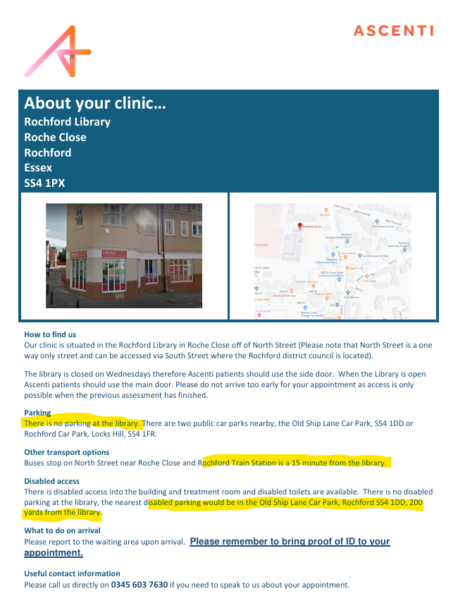

A Blue Badge is issued to people living with mobility issues, for display in their cars. It enables them to park near their intended destination, and thus minimise issues associated with transporting themselves from their vehicle. The invite for my mother’s assessment states there is no on-site parking at the mobility assessment centre and the nearest train station is a 15-minute walk away. The first question asked at the assessment: “*How did you get here today?”*

Figure 2: Blue Badge mobility assessment instructions in Rochford, Essex, 2024

So, what is such discourse really saying? Perhaps a discourse analyst would seek maps of other UK Independent Mobility Assessment Centres, commissioning documentation from the council(s) that subcontract mobility assessments, government policy documents and Hansard records, to explore what is being designed into the assessment system, and whether this county council’s approach speaks to wider themes of non-belief and ableism when dealing with disability. Whether those claiming to have mobility issues are being constructed as liars, that need to be ‘caught out’ by the system.